# Project: Resident Evil

Resident Evil is a system that registers virus spreads across the world. It is a significantly big project, and as such it will have several parts. In this exercise you will land the basis of the application. You will also create the majority of the visual design.

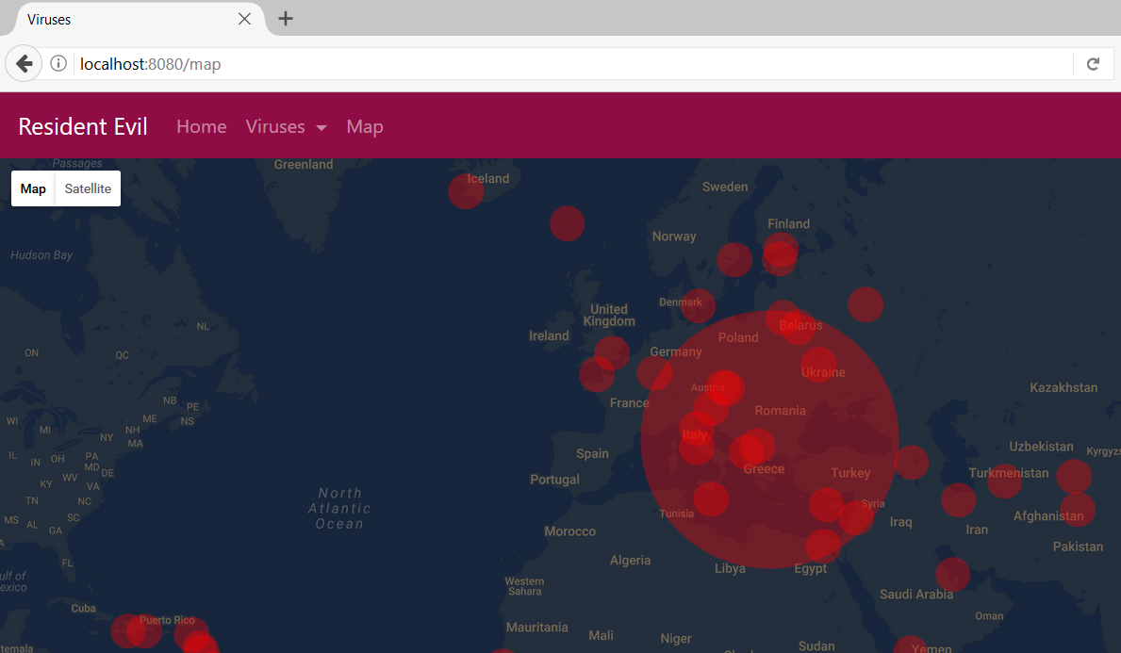

# Exercises: JavaScript & AJAX

Problems for exercises and homework for the [“Java MVC Frameworks - Spring” course @ SoftUni](https://softuni.bg/trainings/1538/java-mvc-frameworks-spring-march-2017).

## Fetching & Loading Data

You have been tasked to modify the Viruses Show page, in a way that it could also visualize Capitals. But how will that happen, they have different properties, we can just put them In the same table… And if we visualize 2 tables it will be ugly.

Well, here’s where JavaScript comes. We will add 2 Radio Buttons at the top of the page, which will act as selectors. Depending on the selected button, different data will be visualized. The page will look like this initially:

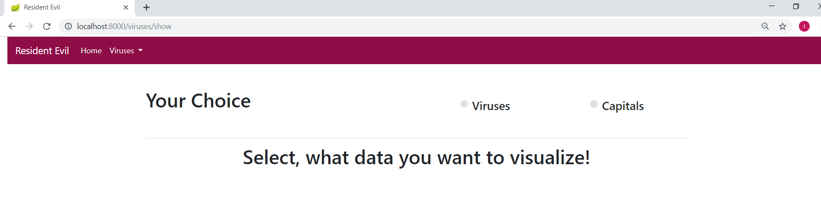

When you choose Viruses, the message below should be deleted and the usual table with all Viruses should be visualized, like in the last exercise.

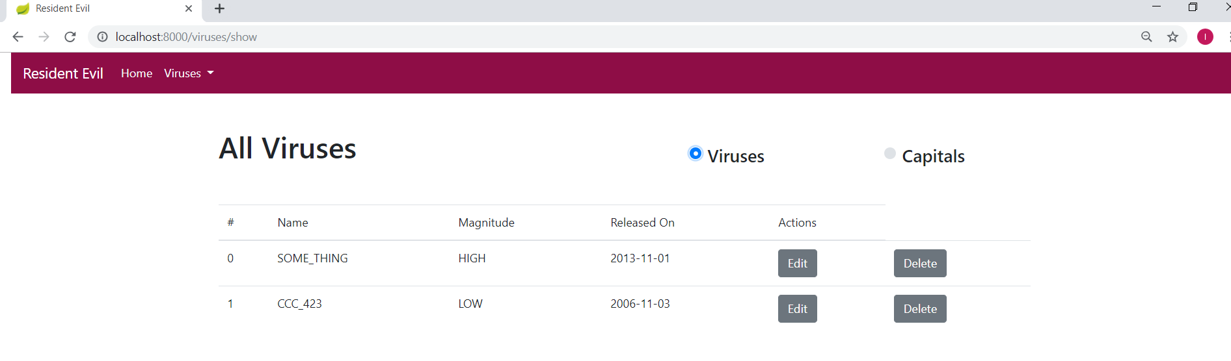

When you choose Capitals, a table with all the Capitals should be visualized.

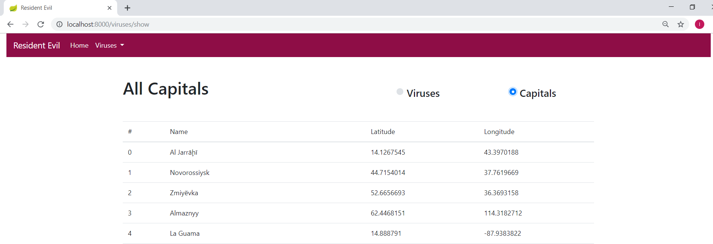

**Both actions** should be done **asynchronously** with **JavaScript** and **AJAX**.

## Virus Form Fragment

The form for Viruses has the same composition for Create, Update and Delete.   
It is quite inefficient to have **3 views** with the same **layout**, so let’s create a little reusability. Extract a Thymeleaf Fragment, which contains the whole Virus Form and include it in the **3 separate pages**. That way you will have no repetition and you will have maximum reusability.

**NOTE**: You will probably need to configure the form as sometimes the **fields** will be **disabled,** and the action will be different.